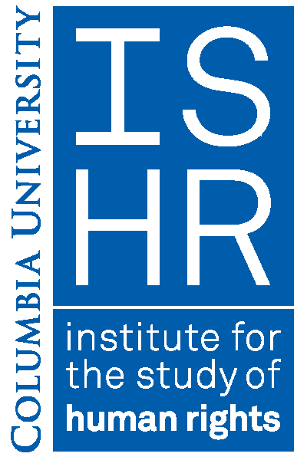
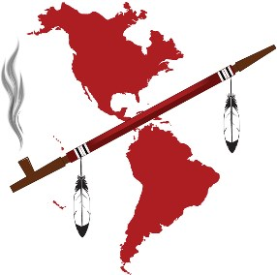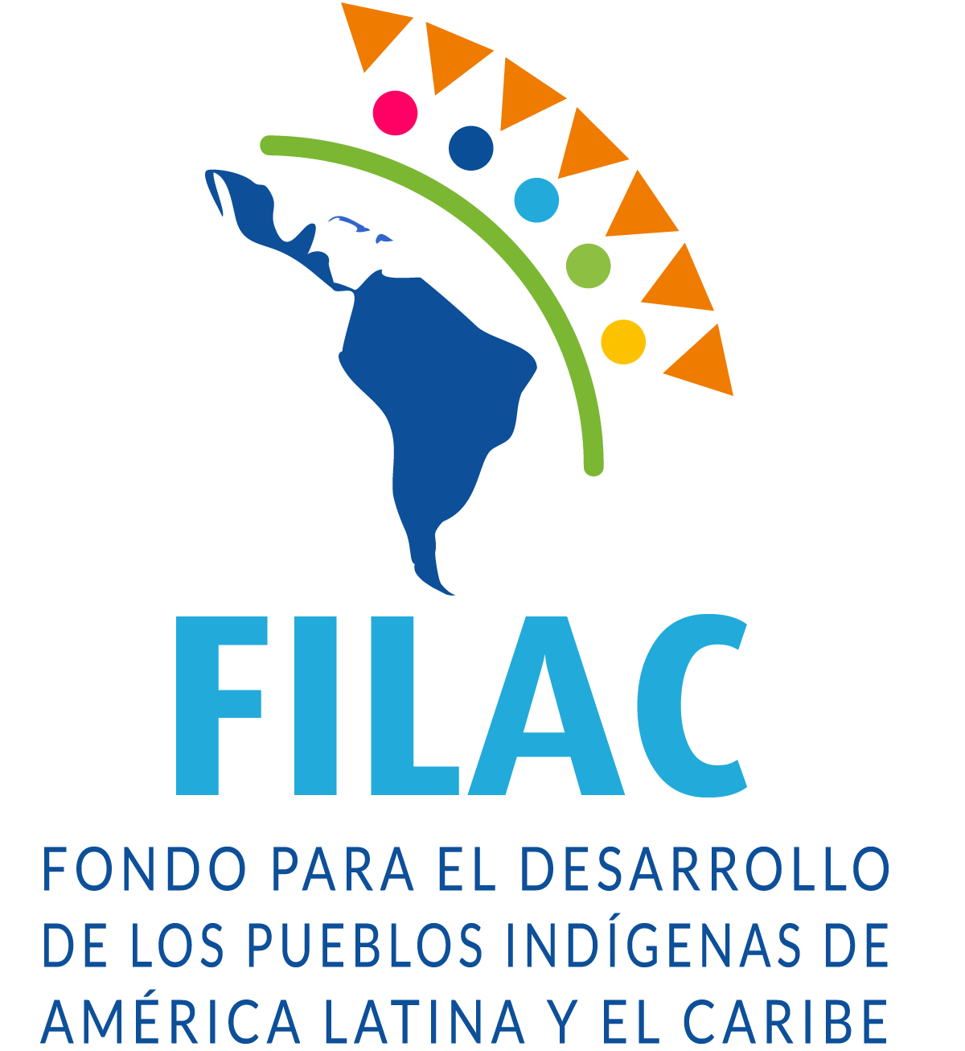

The 3rd International Indigenous Women’s Symposium on Environment and Reproductive Health. Focus: Advancing research & assessing impacts of Environmental Violence on Indigenous Women & Girls at Columbia University, New York City, 14-15 April 2018

Pre-Registration Form

First Name:
Last Name :
Title:
Organization/Institution/Tribe/Nation:
Contact Information/ Email address and phone :
Seminar Attendance (Saturday April 14th AM/PM, Sunday April 15th AM/PM):
Do you need a translation ? ( English/Spanish ) :
Additional Notes:
Please submit this form by email to indigenous@columbia.edu by 25 March 2018
Thank you for your interest and support for the Symposium !
____________________________________________________________________________________________________

Organized and sponsored by the International Indigenous Women’s Forum (FIMI), the International Indian Treaty Council (IITC), the Institute for the Study of Human Rights (Indigenous Peoples’ Rights Program) at Columbia University and el Fondo para el Desarollo de los Pueblos Indígenas del América Latina y el Caribe (FILAC)
Co-sponsored by: MADRE; Alaska Community Action on Toxics; Tribal Link; and Columbia University’s Center for Gender and Sexuality Law, Native American Law Students Association, If/When/How: Lawyering for Reproductive Justice, Law School, Center for the Study of Social Difference and Center for the Study of Ethnicity and Race.

